CLUB SUCCESS PLAN

London Victorians Committee 2019-2020

- President Paulina Dabrowska
- VP Education Ariel Elboim
- VP Education 2 (Secretary) Chris Wedgwood
- VP Membership Jackie Gallego
- VP Membership 2 (Sgt at Arms) Agatha Amachee
- VP Public Relations Lucy Rosa & Raj
- Treasurer Florian Bay
- VP Mentoring Stephanie Walker
- VP Events/ PR Malwina Palinska

- DCP Target

GOAL 10 DCP Points (President’s Distinguished) by year end (June 30th 2020), with an interim objective of 5 DCP points by the end of Dec 2019 and all 10 by end of April.

Current Status:

Total of 6
Club Goals | Achieved | Club Goals | Achieved
Two CC awards |  | P1 Four Level 1 awards
Two more CC awards |  | P2 Two Level 2 awards
One AC award |  | P3 Two more Level 2 awards
One more AC award |  | P4 Two Level 3 awards
One CL/ALB/ALS/DTM award |  | P5 One Level 4 award
One more CL/ALB/ALS/DTM award |  | P6 One Level 5 award

- Membership Target

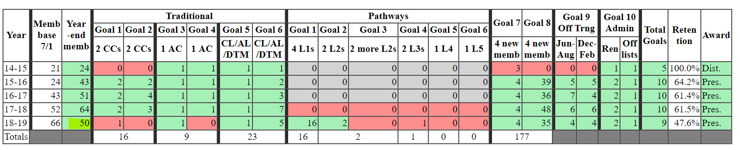
GOAL –
At least 60 members throughout the year. Currently (from July 2019)– 55

Guest conversion rate goal – 30%. Currently -4 guests on average with a conversion rate 12.6%

District initiatives:
Smedley Award – 1st Aug – 30 September (at least 5 – ideally 10+)
Beat the clock challenge – 1st May – 30th June 2020 [2019 - Bronze (5+), aim for Silver (10+) next year]

Q: What is the maximum number of members to accommodate demand for speech slots?
What is the plan in case the club grows too big?
Extra meeting a month for advanced speakers/ icebreakers?

How to achieve the GOAL?
- Attracting more guests and improving guest retention (Web search, CRM, Workshops, Linkedin, Meetup, professional networking – open meetings).
- VPM to follow up in a timely manner – automation
- Bring a friend initiative/ referral prize – Amazon voucher
- Offer 1st month for free if decides to join by end of renewal period

- Membership Retention

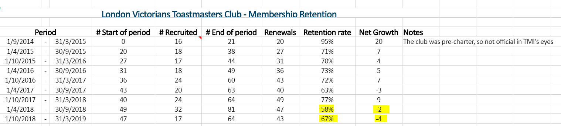

GOAL:
Improve the retention rate to 70% (TMI Dashboard) and submit renewals on time

District initiative:
Pizza Challenge - Renew 20+ members by Sept 30th (renewals open from Aug 12th), Retain 80% of members
How to achieve the GOAL?

Members’ satisfaction insights
- Moments of truth score as a benchmark – main areas of improvement
- Quarterly member survey
- 1:1 mentor – member session to understand the needs and follow up

Members’ engagement
- Increase the average number of meeting participants to 22 (currently 19 – 49 meetings). We have a minimum of 15 roles to be filled at a standard meeting with 4 speakers.
- Introduce assistant club executive roles, introduce new supporting roles, involve members in committee activities early on
- Visits to other clubs as a GE/ Speaker
- Awards, encourage participation in competitions (particularly important for eligibility for the Autumn Contest)
- Set member education goals and monitor attendance
- Variety of meetings adapted to member abilities (special meetings, extra meeting for advanced/ icebreakers)

Social activities:
  - Pub master on a weekly basis
  - Monthly social events – fixed date

- Club marketing and PR

GOAL: Increase online presence and LV reputation in a wider Toastmaster

How to achieve the GOAL?

Online: Facebook likes, Facebook live, Google reviews, Instagram account, regular engaging content on all channels (social media monthly rota?), Linkedin profile, CRM – MailerLite (Speak with Andy O’Sullivan London Cardinals).
Offline: GE exchange (at least 2 per month and at least 1 member to visit another club per month), Megameetings, Meeting invitation cards to be carried by members, Professional workshops (TM visitors from other clubs – free participation in exchange for GE), Open meetings – networking session, Engaging HR in local offices, Civil service network
- Increase the number of Education Awards Achieved
District initiative: 1:70:100 - Every member to achieve at least 1 education award (60!)
How to achieve the GOAL?
- Every member to agree their education goal for the year with the VPE and mentor to monitor their performance against the goal
- Pathways leaderboard displayed at every meeting
- All members to register with pathways by end of August
- Awards for members who achieved the level

- Effective Mentorship Program

GOAL
Strengthen the mentorship program, ensuring that all members, both new and experienced, are offered a club mentor within a week from joining and have a mentor for a minimum of their first 4 speeches, including the end of Level 1 Pathways.
Buddy up programme for professional networking (Linkedin Toastmaster group
More members to become mentors

