Moments of Truth
D91 25th July 2021

1/ First Impressions

2/ Membership Orientation

3/ Fellowship, Variety and Communication

4/ Program Planning and Meeting Orientation

5/ Membership Strength

6/ Achievement Recognition

Ressourses: https://drive.google.com/drive/folders/13XF1xu_KTQmZZLPfceNGdKfOpyRFzxu0?usp=sharing

1/ First Impressions

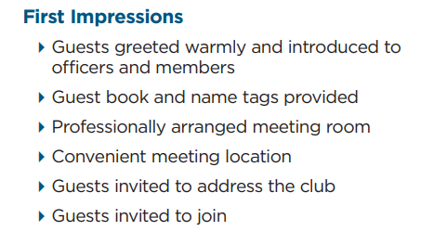-

2/ Membership Orientation
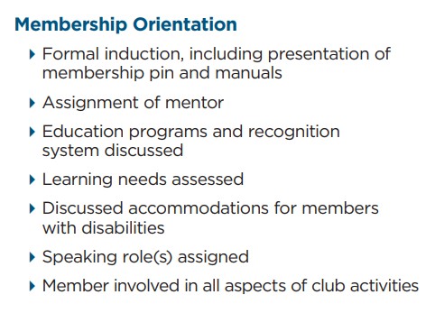
-

3/ Fellowship, Variety and Communication

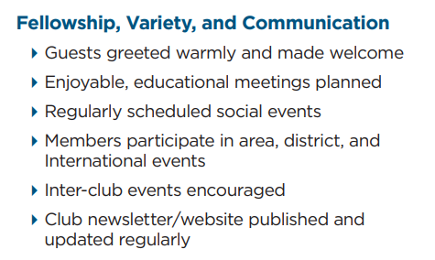

4/ Program Planning and Meeting Orientation
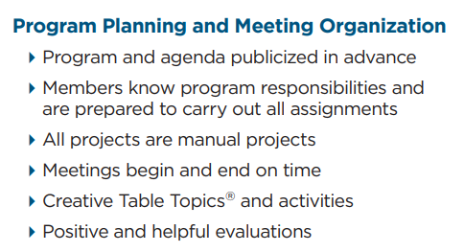

5/ Membership Strength
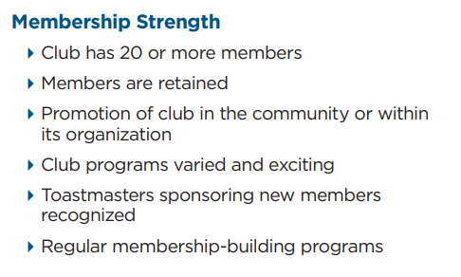

6/ Achievement Recognition [Gitel Hesselberg / Moe Aye / Venice Rowe]
